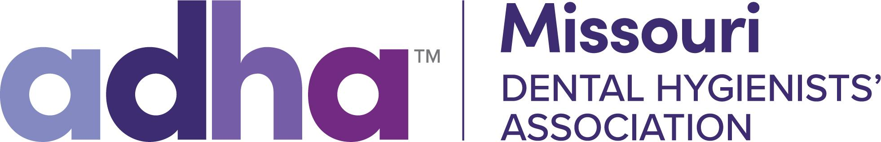

MDHA Legislative Alert

There is currently a bill in the Missouri Legislature, HB 1847, sponsored by Rep. John Hewkin-R-Cuba, MO that will allow to expanded licensure portability for dentists and dental hygienists. The bill will help increase dental manpower in Missouri if one already has a license in another state along with the other requirements. (See MDHA flier). It is a bill particularly pushed by the Dept. of Defense for the military and for others who often relocate.

There will be a hearing on Tuesday, Jan. 13th in the House Economic Development Committee and it would be helpful to e-mail the Chairperson, Rep. Sherri Gallick and the Committee Members (if possible) to express your support for the bill.
It can be short and sweet and you can put more personal information into your note on how this bill will help Missouri.

Ex.
The Honorable (the representative’s name)
Chairperson (or Committee Member)
House Post Office
Date

Dear Rep. Gallick

I am a licensed dental hygienist in Missouri and am writing to express my support for HB 1847 which will be heard in the Economic Development Committee on Jan. 13th. This bill allows for a Dentist and Dental Hygienist Compact which will improve licensure portability in our state. Compacts are not new to Missouri, as they have helped many other professionals increase access to services and care. Please vote to move this bill forward. Thank you.
Sincerely,
Your Name and Contact Info
https://house.mo.gov/Committees.aspx?cluster=true&year=2026&code=R
Here are the Committee Members to write. Only Rep. Gallick is the Chairperson.

https://house.mo.gov/MemberDetails.aspx?year=2026&district=120 Bill sponsor is a pharmacist from Cuba, MO, Rep. John Hewkin

https://house.mo.gov/bill.aspx?bill=HB1847&year=2026&code=R Copy of bill

https://documents.house.mo.gov/billtracking/bills261/sumpdf/HB1847I.pdf Bill summary

Questions: E-mail dbomkamp@sbcglobal.net

